**“E-KETHA” : ENRICHING RICE FARMER’S QUALITY OF LIFE THROUGH A MOBILE APPLICCATION.**

2022-81

Project Proposal Report

Salika Madhushanka W.J

P.Y.D Jayasinghe

H.H.W.M.Binuka Sihan Paranagama

K.M.Umesh Ranthilina

B.Sc. (Hons) Degree in Information Technology

Department of Computer Science and

Software Engineering

Sri Lanka Institute of Information Technology

Sri Lanka

February 2022

**“E-KETHA” : ENRICHING RICE FARMER’S QUALITY OF LIFE THROUGH A MOBILE APPLICCATION.**

2022-81

Project Proposal Report

Salika Madhushanka W.J – IT19101620

P.Y.D Jayasinghe – IT19117256

H.H.W.M.Binuka Sihan Paranagama – IT19129372

K.M.Umesh Ranthilina – IT19240152

Supervisor: Mr. Adeepa Gunarathna

Co Supervisor: Ms. Amali Upeka Gunasinghe

B.Sc. (Hons) Degree in Information Technology

Department of Computer Science and

Software Engineering

Sri Lanka Institute of Information Technology

Sri Lanka

February 2022

**Declaration, Copyright Statement and The Statement Of The Supervisor**

We declare that this is our own work and this proposal does not incorporate without acknowledgement any material previously submitted for a degree or diploma in any other university or Institute of higher learning and to the best of our knowledge and belief it does not contain any material previously published or written by another person except where the acknowledgement is made in the text.

|  |  |  |
| --- | --- | --- |
| Name | Student ID | Signature |
| Salika Madhushanka W.J | IT19101620 |  |
| P.Y.D Jayasinghe | IT19117256 |  |
| H.H.W.M.Binuka Sihan Paranagama | IT19129372 |  |
| K.M.Umesh Ranthilina | IT19240152 |  |

The supervisor/s should certify the proposal report with the following declaration.

The above candidates are carrying out research for the undergraduate Dissertation

under my supervision.

------------------------------ ------------------------------

Signature of the supervisor: Date:

------------------------------ ------------------------------

Signature of the supervisor: Date:

# **ABSTRACT**

In our country of Sri Lanka, rice is the most common type of food that is consumed daily. Due to that rice farmers face a huge amount of stress to supply according to the massive demand. This is happening while they are farming in poor conditions such as, amongst diseases and pests that harm rice crops with the inclusion of weeds that plague the field. They also have difficulties finding the correct fertilizers and the amount that are needed for the crops to grow properly. Another issue discovered, was that there some rice plants are underdeveloped, and farmers lack the understanding about proper treatment. These topics were chosen according to multitude of statistics including losses due to all insects, losses due to all diseases, losses due to all weeds, potential production harvested, and total potential production lost before harvest being found respectively at 34.4%, 9.9%, 10.8%, 44.9% and 55.1%. The aim is to develop a mobile application that will help farmers solve these problems. The application will use image processing to analyze crops to find solutions stored at a cloud database. Then after machine learning and deep learning will be used to recommend appropriate solutions.

Keywords :- machine learning, image processing, deep learning

# **TABLE OF CONTENTS**

**ABSTRACT** iv

**TABLE OF CONTENTS** v

**LIST OF FIGURES** vi

**LIST OF TABLES** vi

**1.** **INTRODUCTION** 1

**1.1** **Background** 1

**1.2 Literature Survey** 3

**1.3** **Research Gap** 4

**1.4** **Research Problem** 5

**2.** **OBJECTIVES** 6

**2.1 Main Objectives** 6

**2.2 Specific Objectives** 6

**3.** **METHODOLOGY** 7

**3.2 Research Area** 8

**3.3 Requirement Gathering And Analyzing** 8

**3.4.1 functional requirements** 8

**3.4.2 Non-functional requirements** 9

**3.5 Design** 9

**3.6 Tools and Technologies** 9

**3.6.1 Tools** 9

**3.6.2 Technologies** 9

**3.7 Implementation** 9

**3.8 Testing and Maintenance** 10

**4.BUDGET** 10

**REFERENCE LIST** 11

# **LIST OF FIGURES**

Figure 1:Rice importers by Sri Lanka (2014-2018), by main importing countries 1

Figure 2: Rice growth 2

Figure 3:system overview 7

# **LIST OF TABLES**

Table 1: Comparing existing application and our application features 4

Table 2:Budget 10

# **INTRODUCTION**

## **Background**

Rice farming, which have been cultivated by humans since 3000-2500 BC have been one of the main staple sources of sustenance. This is due to multiple beneficial qualities that it provides such as being rich in carbohydrates, fiber, selenium and even vitamin B. Since rice mainly grows in hot and humid climates, Asia is the current most producer of rice in the world. In particular Chinese, Indian and Sri Lankan people tend to eat rice on a daily basis.

When we look at a country like Sri Lanka, due to rice being high on demand local farmers struggle massively to meet the said demand. This can be to the point of even having to import rice from overseas. As shown in graph below.

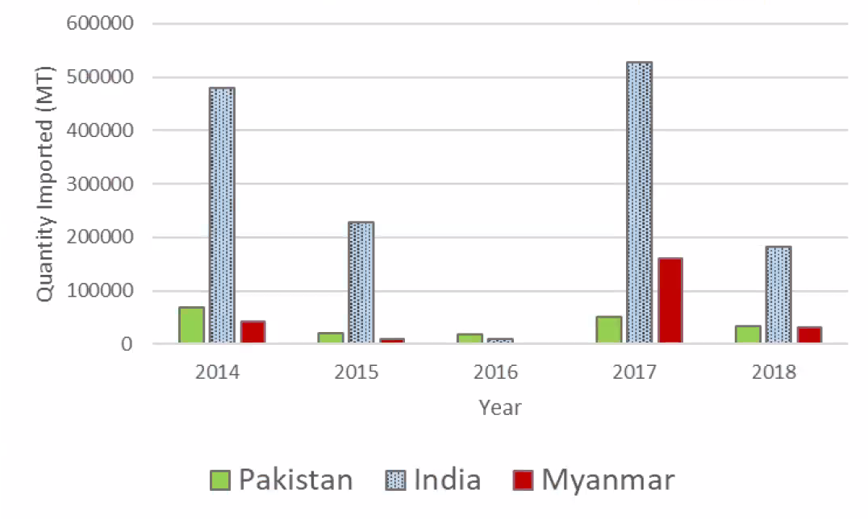

Figure 1:Rice importers by Sri Lanka (2014-2018), by main importing countries

There are multitiude of reseons on why rice farming can be slowed down when it comes to local and foreign rice farming. Howerver in particular they effect Sri Lanka farmers more due to lack of proper technology and knowledge. The four most important of the reasons are

* Pests and dieseas – The many pests and dieseas that could harm rice crops.
* Weeds – The weeds that absorbs nutrients from the soil.
* Fertilizer missuse – The improper use fertilizers that harms rice crops.
* Growth problems – Issues when it comes to the growth of rice crops.

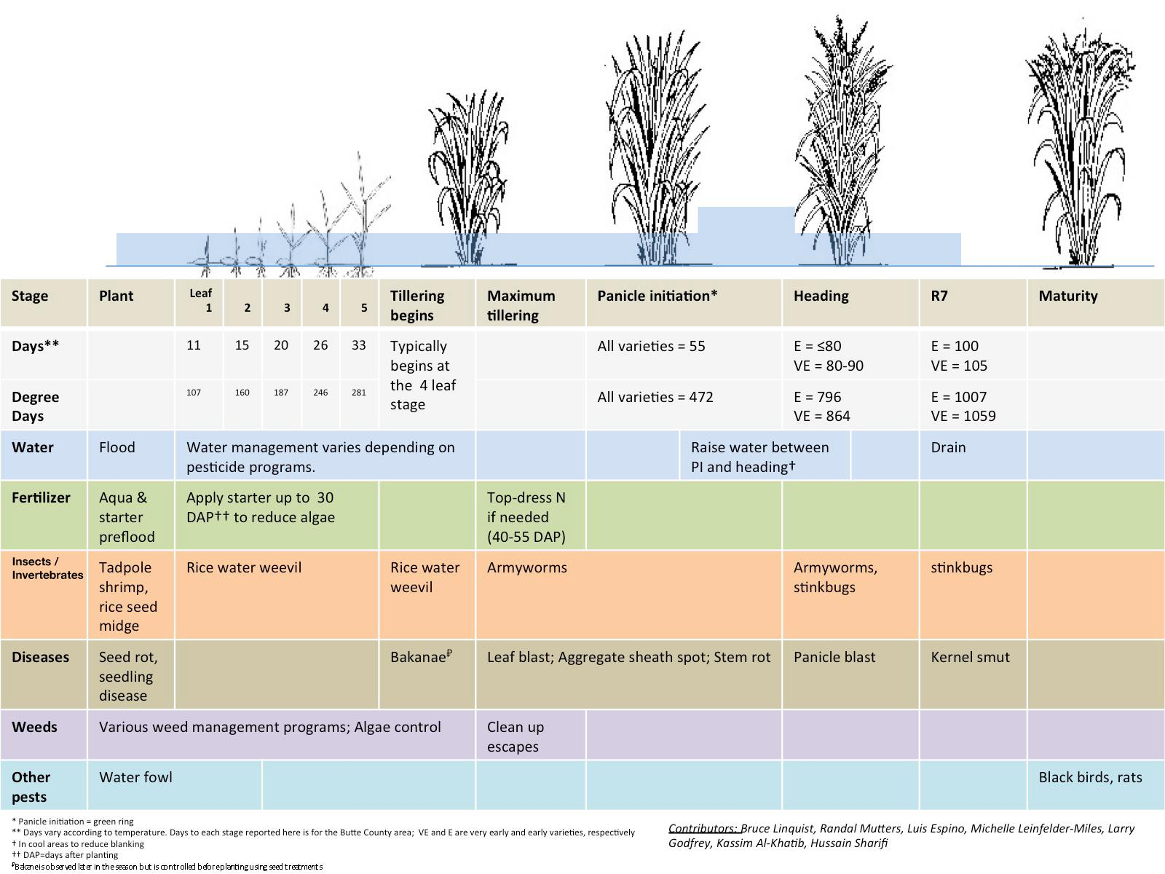

Figure 2: Rice growth

## **1.2 Literature Survey**

**1.2.1 Crop Farmers Mobile Application**

Help the farmer with summary information about crops, fruits, and vegetables. Climatic and Soil Requirements, Avocado, Banana, Beans, Carrot, Jackfruit, Cucumber, Garlic, Irish Potato, Lettuce, Sorghum, Watermelon, Onion, Bell Peppers and Peppers, Pineapple and Eggplant sour Info explains how. The app also describes the most common causes of pests and diseases, symptoms, how they spread, and prevention and control measures. Where possible, app will advise on suitable farming methods to control crop pests. This app can be used as a guide for new farmers, or anyone involved in farming around the world. Learn new farming techniques/methods to avoid attacking your crops. It also provides information on best practices for to follow to improve farmers' performance in growing these crops.[11]

**1.2.2 Pest Identification using Image Processing using Neural Network**

This study is done by Johnny L. Miranda, B. Gerardo, Bartolome T. Tanguilig, Sajad Sabzi with the goal of classifying pests in crops. Pest infestation in rice production is a challenging task for crop technicians and farmers. Pest infestation can cause serious losses and also affect the income of farmers. Decisions for pest predictions can be made by estimating the density of farmers. Existing detection techniques for these species involve the use of various traps to detect their presence. In this study, an identification system was developed for automatic detection of field insect pests. Continuous monitoring by a wireless camera for video recording is done by catching the insect with a sticky trap. Various imaging techniques are used to identify and extract the captured insect. Neural network was used to identify the extracted insect pests. The new automated detection system developed in this study provides reliable detection [13].

* + 1. **Weed Classification for Site-Specific Weed Management Using Automated Stereo Computer-Vision**

This study is done by Mojtaba Dadashzadeh , Yousef Abbaspour-Gilandeh ,Tarahom Mesri-Gundoshmian , Sajad Sabzi with the goal of classifying weed in a specific site using stereo vision system to distinguish rice plants and weeds. This system is further augmented using an artificial neural network and two other metaheuristic algorithms, them being y particle swarm optimization (PSO) and the bee algorithm (BA). With stereo videos being recorded of the site beforehand and decomposed into singular frames, rice plants were extracted out using the color, shape and even texture. Then the previously mentioned metaheuristic algorithms were used to optimize the neural network and classify the weed detected as well. According to K-nearest neighbors (KNN) classifier this reached f 88.74% and 87.96% for right and left channels without accounting arithmetic or the geometric means as the basis and with it o 92.02% and 90.7% respectively [12].

**1.2.4 A nutrient recommendation system for soil fertilization based on evolutionary computation**

This study [11] is about predicting the fertilizers for different crops and give nutrients recommendations by analyzing the crop fertility and yield production. However, this application is limited to selected fertilizers (Nitrogen (N), Phosphorus (P), and Potassium (K)). This recommendation done by using improved genetic algorithm (IGA) which will uses time-series sensor data and recommends various crop settings. By analyzing the way that fertilizer works, the application will be able to give instructs farmers to get the maximum yield output [14].

**1.2.5 Rice Crop Height Measurement Using a Digital Image Processing**

This is a plant height identification method currently in operation in Thailand. It detects the height of the plant and shows the height of the plant to the user. But it does not use a mobile app.

Here is an automatic image processing method to identify the user based on the photos taken by a digital camera mounted on a field server, including a marker bar used to describe the height of the rice plant. Height can be assessed by analyzing the uploaded image obtained by the user. Digital image processing for analysis uses four steps to automatically measure rice crop height. Therefore, it is possible to get the height of the rice tree [15].

## **Research Gap**

|  |  |  |  |  |  |  |
| --- | --- | --- | --- | --- | --- | --- |
|  | 1.2.1 | 1.2.2 | 1.2.3 | 1.2.4 | 1.2.5 | E-Ketha |
| Detect diseases | Yes | No | No | No | No | Yes |
| Detect pests | No | Yes | No | No | No |  |
| Detect weeds | No | No | Yes | No | No | Yes |
| Provide guidance manage fertilizer | No | No | No | Yes | No | Yes |
| Detect growth | No | No | No | No | Yes | Yes |

Table 1: Comparing existing application and our application features

## **Research Problem**

Several concerns were found that negatively affect the farmers and the rice crops that reduce the productivity along with profit.

* The first major issue when it comes to paddy is the prevalence of diseases that are native to rice. With new diseases and sicknesses being found each passing day, it becomes difficult for the common farmer to identify and treat them. What is closely related to diseases are pests and other unwanted insects that are also attracted to the crops. These pests might be the reason that diseases are created from the plant in the first place, as well as the reason why diseases are distributed. Pests, even while not spreading disease, might make the crops unsanitary for human consumption [1,5,6].
* The second issue is the growth of unwanted weeds that are prevalent in paddy fields. While weeds do not directly harm rice crops, weeds absorb nutrients from the paddy fields that should have gone for the development of healthy rice plants. The identification of weeds however is not difficult for the common farmer, but the true challenge lies in the recognition of proper weedicide to combat the identified weed. This is due to vast amount of weed types and the equally wide variety of weedicides being difficult to recollect for the common famer [2].
* The next issue is the recognition of suitable fertilizers that are needed for the crops to grow healthy and abundant. Farmers due to lack proper guidance tent to use incorrect fertilizers, fertilizers that have considerable side effects or even the correct fertilizers in wrong amounts thus making it harmful. This has become a major problem in Sri Lanka today due there being reports of various health concerns for the consumer such as increasing the risk of Alzheimer’s disease and Diabetes [3]. The environment is also damaged as a repercussion, examples being contaminated waterways and the destruction of algae [8,9].
* Finally, there have been concerns about the fact that, farmers are lacking in knowledge when it comes to the lifecycle of rice crops and whether the rice plant is in the proper phase of the lifecycle at the given time. This can cause mistreatment or no treatment altogether thus resulting poor harvest and there by profit. [4,7].

## **OBJECTIVES**

### **2.1 Main Objectives**

The main objective of this research project is to help farmers with their paddy fields and make life easier for them. The farmers will be receiving proper guidance and techniques so that producing a steady abundant yield of crops to match the great demand of consumers. Farmers will have the opportunity of exchanging information among one-another so as to regulate knowledge.

### **2.2 Specific Objectives**

1. Detection of pests and diseases using image processing and finding solutions by applying machine learning.

User will have the ability to take a picture of diseased or a pest-ridden crop to identify the type of disease or pest. After identifying the pest or disease type the application will present the most suitable solutions to treat the crops.

2. Detection of weeds using image processing and finding solutions by applying machine learning.

User will have the ability to take a picture of weeds in the paddy field aerially or weed plant itself to identify the hotspots or the type. Then application will present the most suitable solutions to remove the weeds without having to harm the rice crops.

3. Identification of fertilization information according to the size of paddy field and the fertilizer using image processing, then after providing the instructions by applying machine learning.

User will have the ability to take a picture of rice fields and fertilizers. Then the application will help to identify the best utilization methods with detailed instructions including amount and dosage of fertilization that could be used to aid their growth.

4. Rice crop growth identification using image processing and giving solutions to debilitated crops by applying machine learning.

User will first need to input the type and the planted date of the rice plant. Then the user has to take a picture of rice plant. Finally the application will provide solutions to the deficient crops.

# **METHODOLOGY**

This section will entail the details on the techniques and mechanisms that are employed to create the “E-ketha” application from the data gathering stage all the way to implementation.

3.1 System Overview

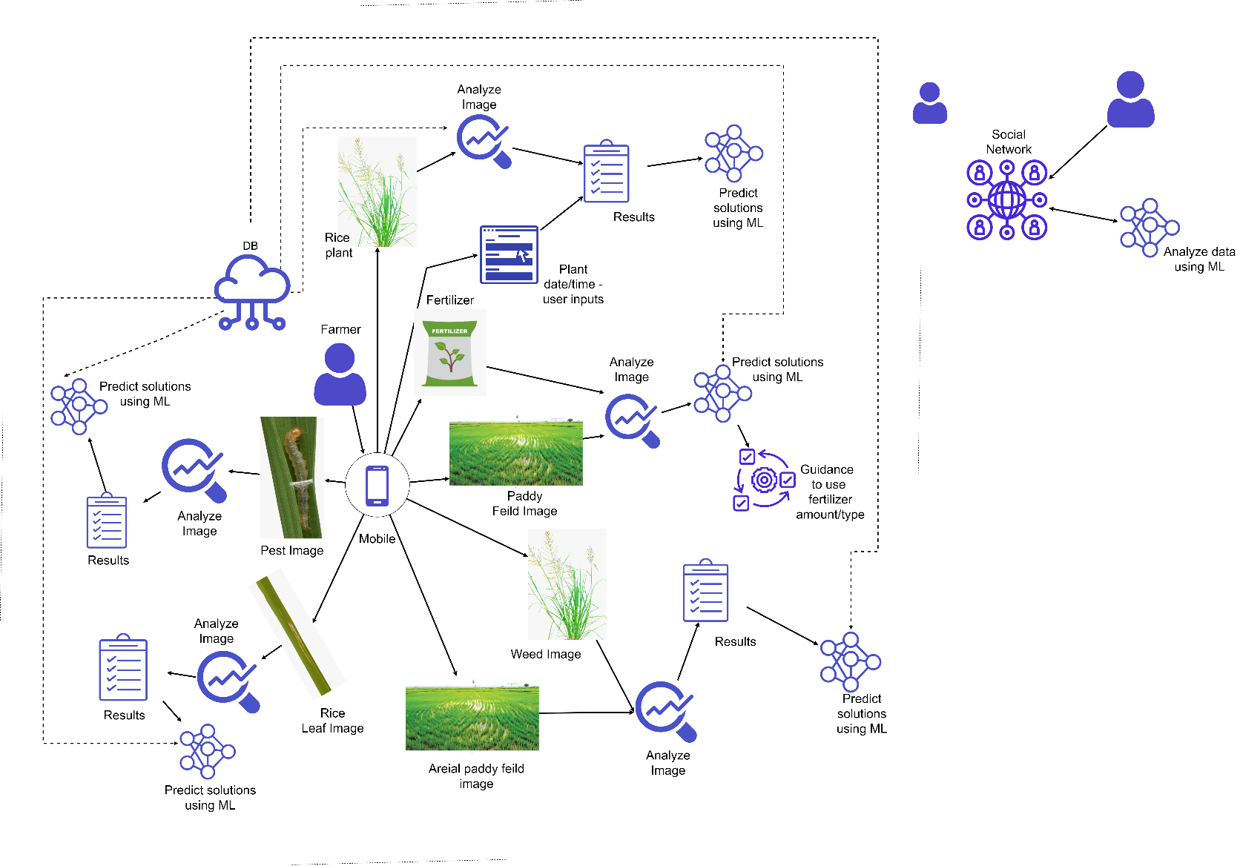

Figure 3:system overview

The proposed E-ketha application will contain four major components. And them being,

* Detection of diseases and pests in order to provide solutions.
* Detection of weeds in order to provide solutions.
* Provide guidance for proper fertilizer management.
* Management of growth in order to provide solutions.

## **3.2 Research Area**

When it comes to research area, four features were identified. Such as Image processing activities, Classification activity, Detection activities and finally solution prediction. In order to conduct the research, deep learning technology has been taken as the core foundation.

## **3.3 Requirement Gathering And Analyzing**

Due to the importance of requirement gathering and analysis, major emphasis was put to this section. Since there is a need for this process to be strictly in accordance with the individual components, below mentioned approaches were used.

* Reading research papers relevant to the research problem.
* Studying existing systems related to our research area.
* Contacted experts in Rice Research and Development Institute(RRDI) , Bathalagoda.
* Met with Sri Lankan paddy farmers.

To get an idea about the research problem, studying related research papers are a must. Next step was to understand what types of systems that already exists, so as to see what are lacking and needs improvements. Finally to see if the proposed solution is viable in the current environment, specialists on the field and traditional farmers were contacted.

### **3.4.1 functional requirements**

* Detect diseases and pests to find solutions.
* Detect weeds to find solutions.
* Provide guidance for proper fertilizer management.
* Management of growth in order to provide solutions.

### **3.4.2 Non-functional requirements**

* Reliability
* Accuracy
* Availability
* Performance
* User friendly

## **3.5 Design**

Design phase encompasses what is needed for the estimation of hardware and system requirements by the creation of a system architecture, due to the needs and specifications being included. The architecture will entail the “E-ketha” application separated into four different components so as to give each member a balanced workload.

## **3.6 Tools and Technologies**

### **3.6.1 Tools**

* Android studio
* PyCharm
* OpenCV
* Jupiter notebook
* DB

### **3.6.2 Technologies**

* Machine learning/Deep learning
* Image processing
* Android – java
* Python

**3.7 Implementation**

**Weed Management**

For the purpose of Weed identification, the ResNet (Residual Network) model was used. This model was chosen in order to answer the issue of vanishing or exploding gradient which is a nuisance in deep neural networks that have a large number of layers. What is meant by vanishing or exploding gradient is the gradient becoming zero or becoming a large number with the increase of layers thus providing a high error rate on both training and test datasets. How ResNet archives this is by using the concept of residual blocks which utilize the technique of skip connections. This skip connections connect activation layers to oncoming layers by skipping the layers in the middle of them. How it decides to skip is by seeing if the next layer is damaging the performance. In particular ResNet50 model is used here due to the reasoning of giving the best results as well as 500x500 pixel size images being used as the dataset. The 50 after the model name is the amount of layers in the model as such ResNet50 contains 50 layers.

The dataset used for the training of the model has 17,509 belonging to 8 different weed species. Normalization was used to preprocess the data in order for better training. Mean and standard deviation was calculated in order to normalize. For training and testing purposes the dataset was split in a 0.8 and 0.2 ratio respectively. Another 0.1 was taken from the training set for validation to be done. As for the hyperparameters for this model, 10 epochs, 32 batch size were chosen as this gives the best accuracies, while the number of classes were 9 due to the 8 weed species and another for negative samples. The learning rate was then chosen to be 0.001 as the learning rate finder function gave that amount as the number with the lowest error rate.

**Pest and disease management**

CustomizedCNN was used as the main model for the disease identification. CNN was chosen due to the it being one of the most basic deep learning models which can take input images and have them differentiated. Three input layers were added in order to customized according to the dataset and this was able to give the best outcome. The data was shuffled, resized and rescaled in order to perform preprocessing. Batch size 32 and 20 epochs were given as the hyperparameters for the best results to emerge. 0.8 and 0.2 split was made for the raining and testing set.

For pest identification AlexNet was used as the model. The reason why AlexNet chosen was due to its relatively short training time compared to other deep learning models. This is because it allows multi-GPU usage thus making use of multiple GPUs if there are present. Normalization and label one hot encoding was performed as preprocessing. 20 epochs, 0.1 learning rate and 32 batch size are the hyper parameters used in this model. 0.8 and 0.2 split was made for the raining and testing set.

**Growth management**

In Order to identify whether the plant is a rice plant or not. For this AlexNet model is used for its special quality which is speed. This is in part due to the multi gpu utilization ability. This enables several graphical processing units to work in tandem with each other. Another strength this algorithm posses nonlinearity which is provided by Rectified Linear Unit (ReLU). This also add to its already impressive speed.

As for the preprocessing, first the integer numbers converted to the floats then performing normalization and finally one-hot encoding the labels. 10 epochs, 0.1 learning rate and 128 batch size are the hyper parameters which worked best and had the lowest error rate. 0.8 and 0.2 split was made for the training and testing set.

In order to measure the height of the rice plant, A python code has been implemented that has the capability to measure the height when the distance to the plant has been inputted.

**Fertilizer management**

CustomizedCNN was used as the main model for the fertilizer identification. CNN was chosen due to the it being one of the most basic deep learning models which can take input images and have them differentiated. Layers of the model have been modified accordingly in order to get the maximum accuracy.

* 4 – Convolutional layers
* 4 – pooling layers

Then a flatten layer and dense layer with SoftMax activation function was added to convert the output of the model to a format which can make the prediction.

As for the preprocessing the dataset random vertical_flip, horizontal_flip, rescale and shuffle features were added.

Finally, in order to get the maximum test and the training accuracy hyperparameters were tuned accordingly,

* Batch size – 32
* Epoch - 90

Maximum accuracy was achieved, according to the previously mentioned configurations.

In order to calculate the area of the paddy field, Mobile device’s GPS has been used. Application was developed so that a user can easily calculate any paddy field part that they want to fertilize. User has to ping the 4 corner locations of the area that required for the fertilization. Then the application will get the latitude and longitude of each location, calculate the area of the paddy field.

## **3.8 Testing and Maintenance**

As the final phase of the SDLC is the testing and maintenance phase which will be done under the discipline of functional and nonfunctional testing. The functional testing will mainly consider the functional requirements of the system and unit testing will be taken as the basis. Then in order to check the nonfunctional requirements such as performance and availability various nonfunctional testing will be conducted. As for the maintenance of the application after the publication various support features will be added.

# **4.BUDGET**

Table 2:Budget

**RESULTS AND DISCUSSION**

1. Weed Management

99.49% training accuracy and 85.62% test accuracy was able to be reached using this particular model as shown in the examples above with the predictions for the test data shown below.

|  |  |  |  |  |  |  |  |  |  |
| --- | --- | --- | --- | --- | --- | --- | --- | --- | --- |
|  | **ChineeApple** | **Lantana** | **Negative** | **Parkinsonia** | **Parthenium** | **PricklyAcacia** | **RubberVine** | **SiamWeed** | **SnakeWeed** |
| ChineeApple | 209 | 0 | 12 | 0 | 1 | 0 | 0 | 0 | 3 |
| Lantana | 2 | 185 | 21 | 0 | 0 | 0 | 1 | 4 | 0 |
| Negative | 14 | 14 | 1635 | 19 | 21 | 47 | 55 | 1 | 16 |
| Parkinsonia | 1 | 0 | 9 | 197 | 0 | 0 | 0 | 0 | 0 |
| Parthenium | 1 | 0 | 15 | 0 | 189 | 0 | 0 | 0 | 0 |
| PricklyAcacia | 9 | 1 | 74 | 13 | 13 | 102 | 0 | 0 | 1 |
| RubberVine | 3 | 0 | 13 | 0 | 0 | 0 | 185 | 0 | 1 |
| SiamWeed | 0 | 1 | 36 | 0 | 0 | 0 | 0 | 176 | 2 |
| SnakeWeed | 35 | 10 | 25 | 0 | 1 | 0 | 0 | 4 | 129 |

# **REFERENCE LIST**

[1] Rahman, C., Arko, P., Ali, M., Iqbal Khan, M., Apon, S., Nowrin, F. and Wasif, A., 2021. Identification and recognition of rice diseases and pests using convolutional neural networks. [online] Available at: <https://www.sciencedirect.com/science/article/abs/pii/S1537511020300830> [Accessed 01 December 2021].

[2] Wang, A., Zhang, W. and Wei, X., 2021. A review on weed detection using ground-based machine vision and image processing techniques. [online] Available at: <https://www.sciencedirect.com/science/article/abs/pii/S0168169918317150> [Accessed 15 December 2021].

[3] B. Khiatah, “The Health Impacts of Chemical Fertilizers,” *amosinstitute.com*. https://amosinstitute.com/blog/the-health-impacts-of-chemical-fertilizers/.

[4] Albizua, A., Bennett, E., Pascual, U. and Larocque, G., 2021. The role of the social network structure on the spread of intensive agriculture: an example from Navarre, Spain.[online] Available at: <https://link.springer.com/article/10.1007/s10113-020-01676-9> [Accessed 18 December 2021].

[5] Ieeexplore.ieee.org. 2021. Detection of Rice Leaf Diseases Using Image Processing. [online] Available at: <https://ieeexplore.ieee.org/abstract/document/9076527> [Accessed 02 December 2021].

[6] Sethy, P., Barpanda, N., Rath, A. and Behera, S., 2021. Image Processing Techniques for Diagnosing Rice Plant Disease: A Survey. [online] Available at: <https://ieeexplore.ieee.org/abstract/document/9076527> [Accessed 02 December 2021].

[7] Ieeexplore.ieee.org. 2021. Information Extraction from Social Network for Agro-produce Marketing. [online] Available at: <https://ieeexplore.ieee.org/abstract/document/6200774> [Accessed 25 December 2021].

[8] “The Hidden Dangers of Chemical Fertilizers -- Occupational Health & Safety,” *Occupational Health & Safety*, 2018. https://ohsonline.com/Articles/2017/12/07/The-Hidden-Dangers-of-Chemical-Fertilizers.aspx?Page=2.

[9] “Fertilisers and the environment,” *www.dpi.nsw.gov.au*, 2021. <https://www.dpi.nsw.gov.au/agriculture/soils/guides/soil-nutrients-and-fertilisers/environment>.

[10] Resources, University of California, Division of Agriculture and Natural. “Crop Development.” Rice.ucanr.edu, rice.ucanr.edu/Crop_Development/. Accessed 24 Jan. 2022

[11] Johnny L. Miranda, B. Gerardo [Online]. Available: [PDF] Pest Identification using Image Processing Techniques in Detecting Image Pattern through Neural Network | Semantic Scholar. [Accessed: 20-Feb-2020].

[12] Dadashzadeh, Mojtaba, et al. “Weed Classification for Site-Specific Weed Management Using an Automated Stereo Computer-Vision Machine-Learning System in Rice Fields.” *Plants*, vol. 9, no. 5, 1 May 2020, p. 559, www.mdpi.com/2223-7747/9/5/559, 10.3390/plants9050559.

[13]“Crop Farmers App - Apps on Google Play,” Google. [Online]. Available: <https://play.google.com/store/apps/details?id=com.bivatec.cropfarmersguide&hl=en_US.> [Accessed: 20-Feb-2020].

[14] “Computers and Electronics in Agriculture | Journal | ScienceDirect.com by Elsevier,” *www.sciencedirect.com*. https://www.sciencedirect.com/journal/computers-and-electronics-in-agriculture (accessed Jul. 31, 2021).